 | Psychiatric Technology Department  VOX: 909-384-8934 or 909-384-8931  E-Mail : MValdez@ValleyCollege.EDU | 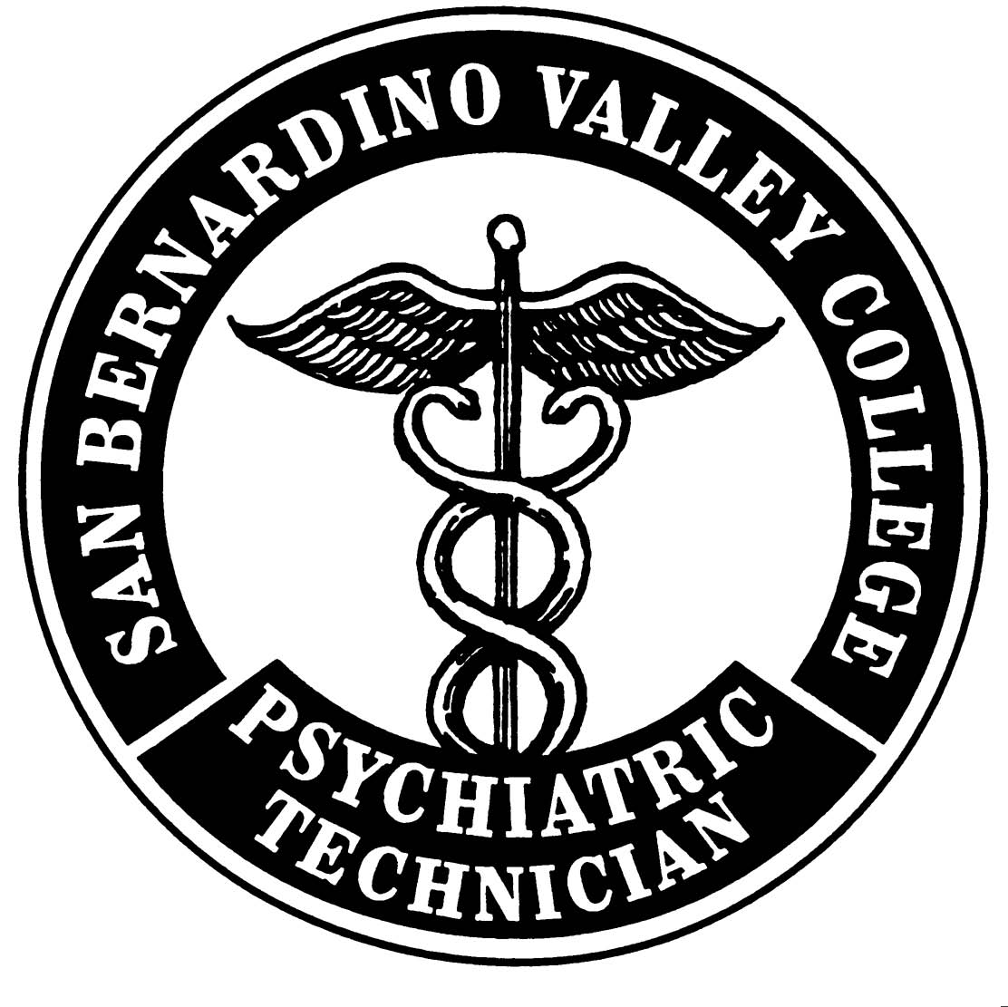
Psychiatric Technology Program Work Sheet
Description:
The Psychiatric Technician Program is a one-year program. The program content areas include nursing science, developmental disabilities, and mental disorders. The program is accredited by the Board of Vocation Nurses and Psychiatric Technicians. Upon completion, the students are eligible to take the BVNPT licensing exam.

Pre-admission & Prerequisites: Submit All with Application
- Complete the San Bernardino Valley College (SBVC) application at https://valleycollege.edu/apply
- Upon submission of the admission application and receipt of your SBVC student ID number complete the Student Orientation at https://valleycollege.edu/online-orientation
- Complete the Guided Self-Placement at: Visit https://valleycollege.edu/webadvisor
  - Log in
  - Select Current Student Menu
  - Under "Academic Planning" select "Online Placement (SBVC)"
  - After completion of the Guided Self-Placement meet with a counselor to develop your education plan
- High school completion (official transcript or G.E.D., AA Degree, BS Degree, or foreign graduate that has been evaluated by AERC (American Educational Research Corporation), or IERF (International Education Research Foundation), or World Education Services. The Board of Vocational Nursing and Psychiatric Technicians (BVNPT) accepts proof of Associate or Baccalaureate degree as evidence of completing a general course of study through the 12th grade.
- Official transcripts of record from other accredited colleges (SBVC or CHC – Submit unofficial copies)
- Bio 155 (Introductory Anatomy and Physiology) with a C or Higher or Equivalent Class (WITHIN 5 YEARS). (4 Units/54 hours, Transferable with a lab.)
- Psychology 100 (General Psychology) with a C or Higher or Equivalent Class (WITHIN 5 YEARS) (3 units/54 hours). (When psych 100 expires, may take PSYCH 110 (Abnormal Psychology), 111 or 112 (Developmental Psychology).
- English 101 (Freshman Composition) with a C or Higher or Equivalent from a US accredited college or university (4 Units with a letter grade).
- Math 095/096 (Intermediate Algebra) or high-level math with a C or better.
- EDUCATIONAL PLAN: It is now required that you have an educational plan on file. This educational plan should include all the courses required to complete your educational goal. Make an appointment with a counselor for an educational plan as soon as possible. If you are a prospective Psychiatric Technician Program student, all prerequisites, general education, and psychiatric technician courses should be indicated on your educational plan. If you are a continuing psychiatric technician student, the remaining degree applicable general education and psychiatric technician courses should be indicated on your educational plan. CONTACT: Elizabeth Banuelos or Erica Begg.
- In addition to earning a grade of “C” or better, students must have a cumulative GPA of 2.0 and be in good academic standing to be considered for admission into the Psychiatric Technology Program.
- Cannot be on academic or criminal probation at the time of applying for the program or during the program.
- Copy of California Driver’s license or ID and Social Security card are required.

Prior to Admission: Immunization Titers – Start Now. Submit when completed
- MMR: Rubella (German measles or 3-day measles), Rubeola (10-day measles, red measles, or measles) And Mumps (MMR= Measles, Mumps & Rubella Vaccine) antibody titer levels indicating immunity.   Hepatitis B Series: # 1, # 2, & # 3  series takes about 4 months (0, 1, 4 months), a protective Hepatitis B surface antibody titer (>10 mIU/mL). antibody titer levels indicating immunity. | - Varicella (chicken pox) the varicella antibody titer levels indicating immunity.  - Tdap (Tetanus, diphtheria, pertussis). Tdap or booster within the last 5 years.  - Influenza: Trivalent, inactivated influenza and H1N1 vaccine.  - Polio vaccine  - COVID vaccine

Provisional Acceptance – Information Provided at the Orientation Meeting. Must pass by scheduled deadlines.
- Live scan clearance – FBI/DOJ (Approximate Fee $67)
- San Bernardino Unified School District clearance (currently no fee).

Please note: If a student is denied access to a clinical site by the clinical agency based on information obtained during the screening process or during the program, the student will not be able to continue in the program.

After Acceptance in the Program (Should be in effect for the duration of the Program.)
- CPR: American Heart Association: Basic Life Support (BLS) & Automated External Defibrillator (AED) for Healthcare Providers No online course accepted.
- Malpractice insurance. Have your graduation date available. Purchase online (Effective 1 Year Only)
- Completed Physical Examinations & Physical Agility Statement on the provided forms with designated health provider signature of who completed the physical. (Within 6 months of start in the program and is effective 18 months)
- Tuberculosis Screening: negative skin test (PPD) within 6 months of start of the program or if history of positive skin test negative Chest X-ray within one year. Note: Tuberculosis screening skin test must be repeated annually while in the program. Students may not enroll in a semester unless their TB screening is valid for the entire semester.
- You will have a mandatory “Review of Requirements Meeting” before class starts.
Important Information to Know
Application
We will only consider applications from students who have completed the prerequisite classes and have all official transcripts submitted to Admissions & Records. Submit official transcripts from other accredited college (other than SBVC and Crafton), and official transcript from high school graduation or equivalent. Students with a college degree from an American accredited college do not need to present evidence of high school graduation.

Check your college e-mail for important updates.

NOTE: Requirements may change without notice.
Mission Statement
The San Bernardino Valley College Psychiatric Technology Program provides quality education and training to students interested in the psychiatric technology field. The mission of the program is to provide the community with graduates who will be competent and professional Licensed Psychiatric Technicians and who are prepared to provide care and treatment to a culturally diverse population.

