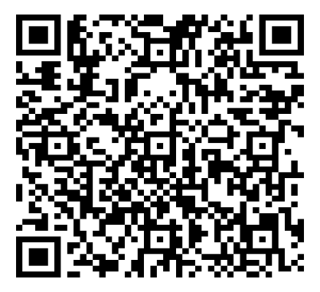

TEAS Prep Info

Session
Monday, September 15th
4:30 PM
Scan the QR code to access the links and study guide
On Zoom: https://sbccd-edu.zoom.us/j/85228245912

