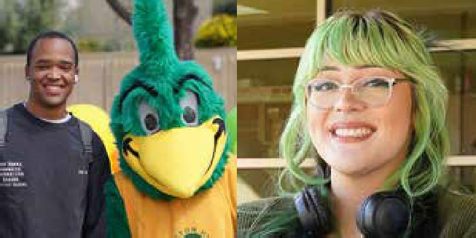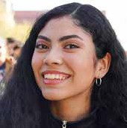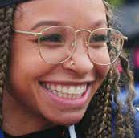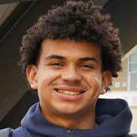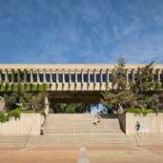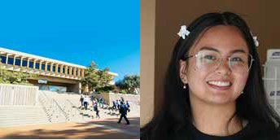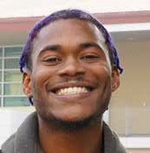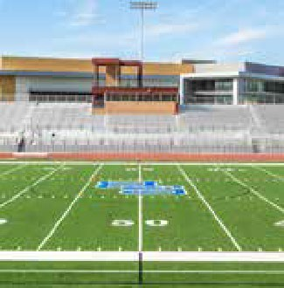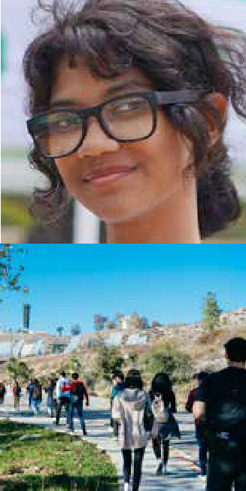

1 of 25

DRAFT



# DUAL ENROLLMENT PLAN

## 2024 - 2025

**CONTENTS**

1. Introduction
2. Dual Enrollment Governance: Building Pathways to Success

Process and Structure

Supporting the Development of Dual Enrollment Offerings

Supporting Admission and Enrollment Processes

Evaluating Program Impact on Student Succes

Dual Enrollment Workgroup Roles and Contributions

Composition:

* **District**
* **San Bernardino Valley College**
* **Crafton Hills College**

1. Strategic Foundations for Dual Enrollment

Dual Enrollment Definitions

Dual Enrollment

College and Career Access Pathways (CCAP) Dual Enrollment

1. Plan Objectives and Strategies

Objective of the Dual Enrollment Plan Expand Dual Enrollment

Diversity Course Offerings

Enhance Student Support Services

Comprehensive Student Support Services

1. Proposed Strategic Action Plan for Implementation

Partnership Development Formal Agreements CCAP Agreements Standard Agreements

Develop Guidelines

Timeline for Action (Goals):

Short-term

Mid-term

Long-term Goals

## CONTENTS

1. Dual Enrollment Data Overview: Enrollment, Demographics, and Educational Goals

Commitment to Equitable Dual Enrollment Growth

Enrollment Overview

Demographic Overview

Course Completion

Educational Goals

1. Equity Measures Embedded in Dual Enrollment Strategy

Targeted Outreach and Inclusion Comprehensive Resource Accessibility Support for Diverse Learners

Continuous Equity assessments

1. Dual Enrollment Support Resources

**Staffing**

Counselor

Program Coordinators

Support Staff

**Funding**

Textbooks & Materials

Technology

1. Dual Enrollment Resource Hub

Resources

1. **Action items**
2. **Outcomes**

Commitment to Equitable Dual Enrollment Growth

Improved Academic Performance

Pathway Completion

Stronger Community Ties

1. **Appendices**

A: List of High Schools Served by SBVC and CHC

B: Memoranda of Understanding with Partner High Schools

## INTRODUCTION

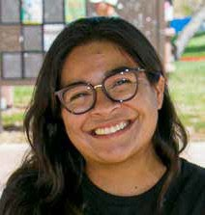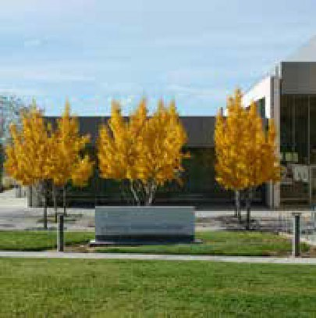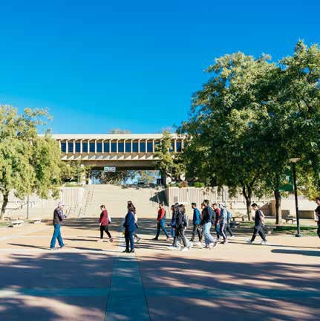

4 of 25

The San Bernardino Community College District (SBCCD) is committed to fostering an inclusive and accessible educational environment. The dual enrollment program provides a critical component, offering students from San Bernardino Valley College (SBVC) and Crafton Hills College (CHC) a head start on their college education. This comprehensive plan integrates the District's strategic goals to enhance educational access and success.

SBCCD serves a diverse community spanning urban, suburban, and rural areas, including San Bernardino, Yucaipa, Redlands, and several other communities. This wide-reaching service area benefits from our commitment to making higher education accessible to all, regardless of socioeconomic background or geographical location. Our mission emphasizes educational equity and lifelong learning, guiding our efforts to reduce educational barriers and open pathways to success for every student.

In line with our mission, our strategic directions for dual enrollment are designed to strengthen connections between high schools and higher education. With a focus on creating seamless student transitions through initiatives like the College and Career Access Pathways (CCAP) agreements, which facilitate dual credit opportunities that prepare students for the workforce or further education. These efforts are supported by ongoing collaborations with local school districts, which ensure that our dual enrollment courses meet the needs and aspirations of the communities we serve, promoting college readiness and success.

DRAFT

This comprehensive plan outlines our continued commitment to enhancing educational access and success, effectively bridging the gap between high school and college education.

### 2. DUAL ENROLLMENT GOVERNANCE:

DRAFT

#### BUILDING PATHWAYS TO SUCCESS

The San Bernardino Community College District (SBCCD) is establishing a dedicated leadership and coordination team to facilitate and enhance our dual and concurrent enrollment programs. This team will be instrumental in implementing strategic measures to ensure the effectiveness and accessibility of dual enrollment opportunities for students from San Bernardino Valley College (SBVC) and Crafton Hills College (CHC). The SBCCD planning team will work collaboratively with key individuals to ensure the boarder goals of the district are being fulfilled. Each college has established teams that work towards meeting their campus dual enrollment goals.

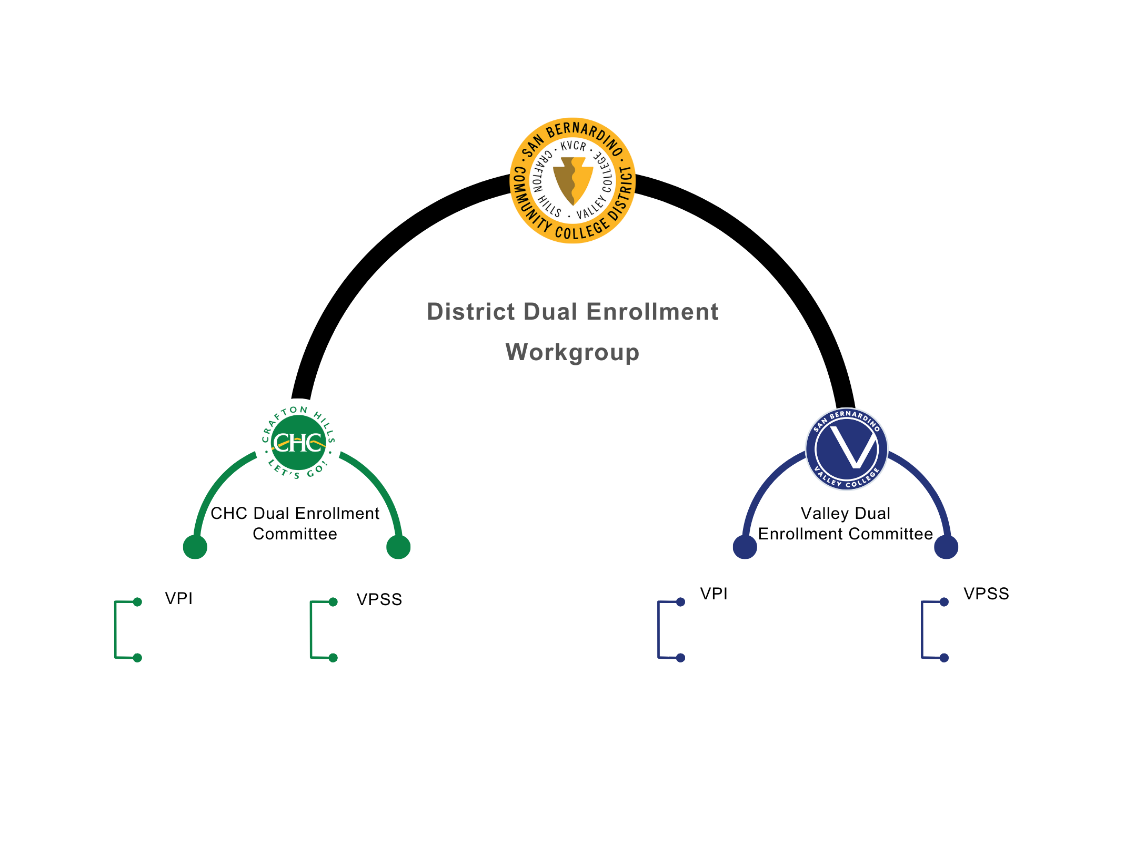

Process and Structure:

SBCCD is developing a structured approach that involves comprehensive planning, ongoing assessment, and continuous improvement to address the growing needs of dual enrollment. This will begin with formulating clear policies and collaborative frameworks involving key district and partner high school stakeholders. Our process will emphasize creating streamlined pathways for students that align with their educational goals and labor market needs, ensuring relevance and rigor.

**Supporting the Development of Dual Enrollment Offerings**: The District will provide resources and coordination to assist colleges in refining and optimizing their dual enrollment programs. This support focuses on enhancing quality and ensuring effective implementation while recognizing that decisions regarding course content, curriculum, and academic standards fall within the purview of each college.

**Supporting Admission and Enrollment Processes**: The District will provide resources and support to help colleges streamline the admission and enrollment processes, ensuring they are equitable and accessible.

**Evaluating Program Impact on Student Success** The District will provide supportive tools, such as data analytics, to assist the colleges in tracking key metrics, including enrollment, completion rates, and student demographics. Each college, through its Institutional Research departments, will continue to lead regular evaluations of the dual enrollment program.

Dual Enrollment Workgroup Roles and Contributions:

SBCCD will establish workgroups that are integral to developing and executing the SBCCD Dual Enrollment Plan. These workgroups will focus on student services and data analytics, aligning with strategic initiatives like 'Vision for Success.' They will consist of representatives from each college, District, and K-12 partners to ensure diverse perspectives are considered. The role of these workgroups will be supportive—emphasizing communication, providing data support, and enhancing operational coordination.

Composition:

The Dual Enrollment Leadership and Coordination Team will comprise faculty members, administrative staff, and counseling professionals from SBVC and CHC. The team will also include representatives from local high schools to facilitate seamless communication and program alignment. This collaborative group will be tasked with the following to review the goals and work towards improving practices and processes to support, expand, and enhance dual enrollment programs. The list below contains the composition of the team.

District:

DRAFT

* Vice Chancellor of Educational & Student Support Services
* District Dean of Educational & Student Support Services
* Executive Director of Research, Planning & Institutional Effectiveness

San Bernardino Valley College:

* Vice President of Instruction
* Vice President of Student Services
* Dean of Academic Success & Learning Services Division
* Associate Dean - Outreach, Recruitment & Educational Partnerships, Admissions & Records
* Dean of Research & Planning
* Dean of Counseling & Matriculation
* Dean of Student Equity & Success
* Director of Secondary Educational Partnerships
* Instructional Faculty Representative (General Education)
* Instructional Faculty Representative (Career Technical Education - CTE)

Crafton Hills College:

* Vice President of Instruction
* Vice President of Student Services
* Dean of Student Services
* Dean of Counseling & Matriculation
* Dean of Research & Planning
* Coordinator of Outreach and Relations with Schools
* Director of Admissions & Records
* Counselor Chair
* Instructional Faculty Representative (General Education)
* Instructional Faculty Representative (Career Technical Education - CTE)

### 3 STRATEGIC FOUNDATIONS

DRAFT

#### FOR DUAL ENROLLMENT

At San Bernardino Community College District (SBCCD), our commitment to equity, access, and student success is at the heart of our dual enrollment program. San Bernardino Valley College (SBVC) and Crafton Hills College (CHC) are integral to this mission. They provide critical pathways for all students, especially those from historically marginalized communities, to access higher education and achieve their academic and career aspirations.

Our dual enrollment initiative is designed to seamlessly bridge the educational journey from high school to college, reducing barriers and demystifying the college experience. By integrating the resources and expertise of SBVC and CHC, we ensure that higher education is more attainable and less intimidating, opening doors to new possibilities for students and their families.

###### DUAL ENROLLMENT DEFINITIONS:

**Dual Enrollment:** Refers to the opportunities for high school, adult school students, or other eligible students to enroll in community college courses as a special admit student and receive college credit while obtaining credit for the enrollment at the student's high school or adult school.

**College and Career Access Pathways (CCAP) Dual Enrollment:** Describes dual enrollment opportunities created by the passage of *AB288, whereupon Community College Districts enter into partnerships with public schools to offer dual credit opportunities that promote seamless pathways from high school to community college for career technical education or preparation for transfer, improving high school graduation rates or helping high school students achieve college and career readiness.

**Standard Dual Enrollment:** Refers to dual enrollment in courses not affiliated with a College and Career Access Pathways agreement; this may include Concurrent Enrollment, Middle College High School, Early College High School, and Adult Dual Enrollment programs.

### 4.PLAN OBJECTIVES & STRATEGIES

DRAFT

The primary objective of the San Bernardino Community College District's (SBCCD) dual enrollment plan is to provide tailored educational strategies that meet high school students' unique demographic and educational needs. This initiative facilitates the creation of pathways to San Bernardino Valley College (SBVC) and Crafton Hills College (CHC), enriching students' educational experiences while still in high school and smoothing their transition into higher education environments.

###### OBJECTIVES OF THE DUAL ENROLLMENT PLAN:

**Expand Dual Enrollment**: Expand dual enrollment opportunities to include more K-12 partners and students within the SBCCD service area while considering each college's resource capacity. This objective will be supported by a data-informed approach, including a review of five-year data trends, sections offered, FTES, course success, and degree and certificate earners to determine where growth is feasible for each college. **Capacity assessments will guide this process to ensure increased enrollments align with each college's ability to provide quality support and instruction.**

Diversify Course Offerings:

Increase the diversity and relevance of dual enrollment courses to align with student interests, Career Technical Education (CTE) opportunities, and emerging workforce demands, making the educational experience engaging and practical. This includes expanding CTE course offerings to provide students with skills directly applicable to in-demand career fields. The District will collaborate with both colleges to ensure a wide variety of courses are available, including those that support technical, vocational, and academic pathways. This balance of offerings will cater to diverse student needs and interests, ensuring equitable access to career-oriented and educational opportunities.

**Enhance Support Services:** Ensure that dual enrollment participants have access to comprehensive resources and guidance to foster academic success and college readiness. This includes targeted tutoring, academic advising, mental health resources, and workshops on college preparedness and financial literacy. Data- driven evaluations will assess the effectiveness of these support services, enabling informed adjustments to better serve students' needs and to close equity gaps in student achievement.

###### STRATEGIES TO SUPPORT TRANSITION TO COLLEGE:

* Strengthen High School Partnerships:

Enhance collaboration with local high schools through regular communication and joint planning sessions. These partnerships help tailor dual enrollment offerings to the specific needs and contexts of the schools, ensuring a seamless educational continuum for students.

* **Targeted Outreach and Recruitment:** Implement outreach initiatives aimed at underrepresented student populations to ensure that all potential students are aware of and feel welcomed into the dual enrollment program. This inclusivity helps demystify the college-going process for families new to higher education.
* **Comprehensive Student Support Services:** Offer robust support services, including academic advising, tutoring, and college readiness workshops. These services are crucial for helping students acclimate to the demands of college-level courses and develop the study skills necessary for academic success.

DRAFT

These strategies collectively foster a nurturing environment that prepares students for the academic rigors of college and builds their confidence as they transition into college students. By aligning high school learning with college expectations, the dual enrollment program effectively bridges the educational gap, making pursuing higher education a more attainable and less intimidating goal for high school students.

### 5. PROPOSED STRATEGIC ACTION PLAN

DRAFT

#### FOR IMPLEMENTATION

To effectively implement the dual enrollment program, SBCCD will execute a comprehensive strategic action plan that integrates our institutional goals with practical, on-ground activities. This plan is designed to facilitate seamless transitions for high school students into post-secondary education and align closely with SBCCD's Vision.

###### PARTNERSHIP DEVELOPMENT:

**Formal Agreements**: Establish and maintain formal partnerships with high schools, clearly defining roles, responsibilities, and mutual goals. This includes both CCAP and Standard agreements. The District will support the colleges by working collaboratively to develop CCAP template agreements that both SBVC and CHC can use. These templates will streamline establishing partnerships, ensure compliance with state regulations, and provide a consistent framework for dual enrollment programs.

**CCAP Agreements:** Focus on creating CCAP agreements that allow high school campuses to host college courses, facilitating a direct pathway into higher education and relevant career fields. These agreements will be crafted to comply with state regulations and match SBCCD's strategic goals, emphasizing equitable access.

**Standard Agreements:** Support the expansion of Standard dual enrollment opportunities, enabling high school students to enroll in college courses offered by San Bernardino Valley College and Crafton Hills College. These courses may be taken on campus or online, providing flexible options for various student needs and learning preferences.

**Develop Guidelines:** Collaborate with SBVC and CHC to support the development of guidelines and processes for Standard dual enrollment, including student eligibility criteria and enrollment procedures. The District will assist in gathering data, providing templates, and facilitating discussions to promote Standard dual enrollment as an additional pathway for students to engage in college-level coursework and explore different academic and career interests.

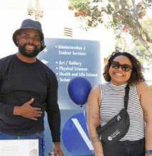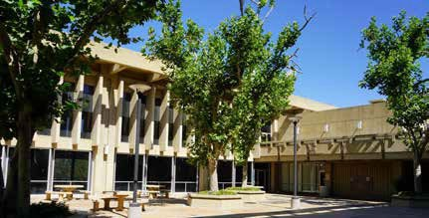

##### TIMELINE FOR ACTION

SHORT-TERM GOALS (2024-2025)

DRAFT

The colleges have successfully finalized partnership agreements and launched initial CCAP and Standard dual- enrollment courses. With these foundational steps completed, the focus now shifts to leveraging the available data from the past five years. This review will inform program adaptations to better address the specific needs of each high school, laying a strong groundwork for targeted program expansion and continuous improvement. This foundational work provides a solid basis for assessing the impact of these initiatives, allowing for informed decisions on expanding dual enrollment opportunities further. Immediate steps include finalizing all partnership agreements and launching initial CCAP and Standard courses.

MID-TERM GOALS (2026-2027):

Focus on assessing the impact of k-12 partnerships and refining the course offerings based on feedback from students and faculty. Data-driven insights will guide adjustments to ensure programs are meeting community and student needs effectively.

LONG-TERM GOALS (2028 AND BEYOND):

Continual evaluation of partnership efficacy and student outcomes, with adjustments to enhance and expand dual enrollment opportunities. Data will continue to inform decisions, ensuring that long-term strategies remain responsive to evolving educational landscapes and the needs of students.

###### INTEGRATION WITH DISTRICT STRATEGY:

DRAFT

The dual enrollment plan will be integral to SBCCD's broader educational strategy, reflecting our commitment to student success and community engagement. By aligning this plan with the District's strategic goals, we ensure that it contributes to a cohesive and comprehensive approach to education.

This plan is dynamic and will be reviewed in meetings to ensure it remains aligned with district goals and responsive to the needs of our students and community. Regular updates on progress and adaptations will be presented, ensuring transparency and ongoing dialogue with all stakeholders.

###### EXPAND MARKETING STRATEGY:

Roll out an innovative marketing campaign focusing on community outreach and digital engagement to increase program visibility by Fall 2025.

###### ENHANCED SUPPORT SERVICES:

**Enhance Support Services**: The District will assist in identifying specific support gaps, such as technology access, and facilitate resource sharing between campuses to address these needs.

**6. Dual Enrollment Data Overview: Enrollment, Demographics, and Educational Goals**

DRAFT

**Commitment to Equitable Dual Enrollment Growth**  
Aiming for consistent growth in dual enrollment participation, with a particular emphasis on increasing access for underrepresented groups. The District will provide data-driven insights to help each college identify opportunities for growth.

**Enrollment Overview**  
SBCCD employs data-driven insights to refine and adapt dual enrollment strategies, ensuring responsiveness to evolving educational demands. The enrollment metrics below demonstrate the continued increase in participation across both San Bernardino Valley College (SBVC) and Crafton Hills College (CHC).

**Enrollment**

|  |  |  |  |
| --- | --- | --- | --- |
| Academic Year | SBVC | CHC | Total |
| 2023-2024 (2023FA, 2024SP) | 1,478 | 651 | 2,129 |
| 2024 Fall | 1,768 | 975 | 2,743 |

The current data indicates a steady increase in enrollment over the past year, reflecting the growing popularity and recognition of the program's value.

**Demographic Overview**  
SBCCD analyzes dual enrollment demographics to ensure equitable access, emphasizing participation across diverse racial/ethnic groups, gender, and age categories. This data guides outreach efforts, ensuring we provide targeted support to underrepresented populations

**Demographic Groups**

|  |  |  |  |  |
| --- | --- | --- | --- | --- |
|  | 2023-2024 AY | | 2024 Fall | |
| Demographic Group | Count | % | Count | % |
| **Race/Ethnicity** |  |  |  |  |
| African American | 138 | 6.5 | 166 | 6.1 |
| American Indian or Alaskan Native | 4 | 0.2 | 6 | 0.2 |
| Asian (incl. Filipino) | 102 | 4.8 | 148 | 5.4 |
| Hispanic | 1,508 | 70.8 | 1,845 | 67.3 |
| Multiracial | 77 | 3.6 | 105 | 3.8 |
| Pacific Islander or Hawaiian Native | 7 | 0.3 | 6 | 0.2 |
| White | 278 | 13.1 | 431 | 15.7 |
| Unreported | 15 | 0.7 | 36 | 1.3 |
| **Gender** |  |  |  |  |
| Females | 1,353 | 63.6 | 1,642 | 59.9 |
| Males | 734 | 34.5 | 1,049 | 38.2 |
| Unreported | 42 | 1.97 | 52 | 1.9 |
| **Age**[1] |  |  |  |  |
| 18 | 588 | 27.6 | 89 | 3.2 |
| 17 | 801 | 37.6 | 1,011 | 36.9 |
| 16 | 467 | 21.9 | 809 | 29.5 |
| 15 | 267 | 12.5 | 475 | 17.3 |
| 14 | 5 | 0.2 | 352 | 12.8 |

**Course Completion Overview**  
The data indicates that dual enrollment students consistently demonstrate strong course completion rates, often exceeding the rates of traditional college students. The following completion metrics reflect student commitment and program effectiveness:

**Educational Goals**  
Understanding the educational aspirations of dual enrollment students helps tailor support services and academic guidance. The table below captures the diverse goals of our students:

**Educational Goals**

|  |  |  |  |  |
| --- | --- | --- | --- | --- |
|  | 2023-2024 AY | | 2024 Fall | |
|  | Count | % | Count | % |
| Undecided Goal | 782 | 36.7 | 894 | 32.6 |
| BA Degree after Associate | 636 | 29.9 | 920 | 33.5 |
| BA degree without an Associate | 110 | 5.2 | 144 | 5.2 |
| Assoc. Degree without transfer | 95 | 4.5 | 97 | 3.5 |
| Vocational Certificate without transfer | 10 | 0.5 | 22 | 0.8 |
| Career Exploration | 39 | 1.8 | 42 | 1.5 |
| Acquire and Update Job Skills | 42 | 2 | 58 | 2.1 |
| Maintain Certificate/License | 10 | 0.5 | 7 | 0.3 |
| Educational Development | 83 | 3.9 | 121 | 4.4 |
| Basic Skills | 23 | 1.1 | 27 | 1 |
| High School Diploma/GED | 287 | 13.5 | 395 | 14.4 |
| 4-year students taking classes | 11 | 0.5 | 13 | 0.5 |
| Non-credit to credit | 1 |  | 3 | 0.1 |

**Conclusion**  
This data-driven evaluation framework ensures that SBCCD's dual enrollment program remains aligned with our strategic goals of equitable access, quality education, and responsive community support. By analyzing key metrics—such as enrollment, demographics, course completion rates, and educational goals—we continue to refine our program to meet the evolving needs of our students and our community.

FF

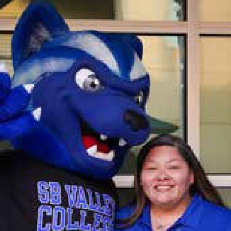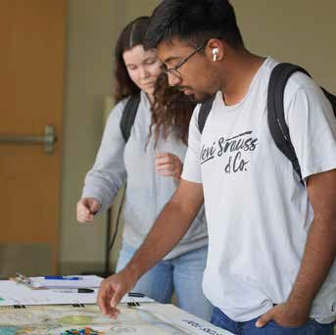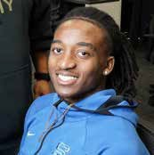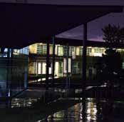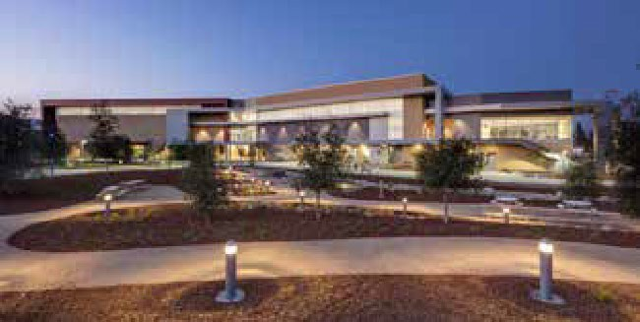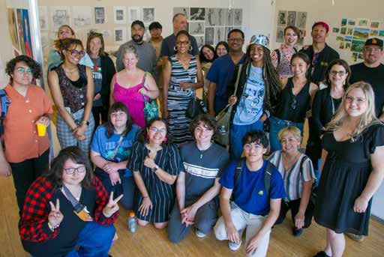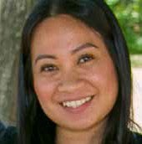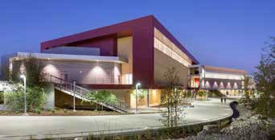

DRAFT

### 7. EQUITY MEASURES EMBEDDED

DRAFT

#### IN DUAL ENROLLMENT STRATEGY

Equity measures have been integrated into the plan and ongoing operations of the dual enrollment program at San Bernardino Community College District (SBCCD) to ensure that efforts to provide equal opportunities permeate every aspect of the program. The District providing all dual enrollment data by July 1 each year, disaggregated by college.

**Targeted Outreach and Inclusion:** Outreach strategies are developed and refined to specifically address the needs and potential of students from underrepresented groups. This includes producing bilingual materials and culturally relevant messaging in regular communications and outreach efforts. Ensuring these strategies are integrated with marketing and recruitment plans allows for effective engagement with a broader and more diverse student population. The District will support these efforts by collaborating on outreach materials, providing media resources, and creating YouTube videos aimed at both parents and students to emphasize the benefits of dual enrollment, including its cost-free nature. These initiatives will include a specific focus on disproportionately impacted (DI) groups identified in the data, with targeted action plans to improve their participation.

* **Comprehensive Resource Accessibility:** It is vital to ensure that every dual enrollment student has access to necessary resources, including textbooks, technology, and transportation. This access is fundamental to the enrollment strategy, ensuring all students can participate fully regardless of their financial background.
* **Support for Diverse Learners:** Student support services include specialized support services for English language learners, students with disabilities, and other groups with unique needs. This integration ensures that these supports are not isolated interventions but part of the fabric of student services, enhancing all participants' educational experience and success rates.

**Continuous Equity Assessments: Continuous Equity Assessments:** Regular assessments of program data are part of a continuous improvement effort. These assessments help identify disparities in access, participation, or outcomes, guiding enhancements in student support services. The District will continue to provide data support and facilitate collaboration between colleges to ensure consistent alignment with equity goals.

By embedding these equity measures directly into strategic actions and making them a core component of the dual enrollment program's operations, the District aims to create a more inclusive, accessible, successful program that genuinely reflects its commitment to equity.

### 8. DUAL ENROLLMENT SUPPORT RESOURCES

DRAFT

STAFFING

The colleges are responsible for developing Dual Enrollment Programs to support the needs of its surrounding communities.The District will support the colleges by collaborating to identify funding opportunities and offering resources that may help enhance counseling services. The District's role will focus on facilitating and convening the Dual Enrollment Leadership and Coordination Team. In addition, to make connections with potential funding sources and provide guidance to align resources with the unique needs of dual enrollment students at SBVC and CHC.

The District may assist in assessing the needs for additional support staff, such as administrative or technical positions, to streamline dual enrollment processes. The colleges will make staffing decisions, with the District offering coordination support, such as facilitating training opportunities and providing access to shared technology resources.

TECHNOLOGY

DRAFT

The District will work collaboratively with colleges to explore and support opportunities for providing technology resources to reduce technological barriers and promote equitable student opportunities.

The District will continue to support access to Learning Management Systems, such as Canvas and Starfish, that facilitate online learning, communication, and student engagement. These platforms are crucial for tracking student progress and providing timely interventions through early alert systems to support dual enrollment student success.

### 

DRAFT

### 11. OUTCOMES

DRAFT



**Commitment to Equitable Dual Enrollment Growth**: Aiming for consistent growth in dual enrollment participation, with a particular emphasis on increasing access for underrepresented groups. The District will provide data-driven insights to help each college identify opportunities for growth while respecting their resource limitations. **Enrollment increased by 48.3% from 2012 to 2024, with a focus on increasing access for Hispanic and underrepresented groups.**



I**MPROVED ACADEMIC PERFORMANCE**

Focus on increasing the course success rates for dual enrollment students, particularly in foundational subjects like math and English. Success will be measured by students passing their courses with grades that reflect mastery, avoiding the pitfalls of D/F grades. Enhanced support structures and resource sharing will help achieve these goals. **Math and English course completion rates are consistently above 95%, reflecting the program's commitment to academic rigor and student support.**



**PATHWAY COMPLETION**

Supporting students in completing their academic pathways, whether that means transferring to a four-year institution, earning a certificate, or gaining career-ready skills. The District will assist in providing necessary data to track students along these pathways, allowing for targeted improvements that align with student needs and college resources. **The program supports academic pathways, with students earning program awards, including Associate's Degrees.**



**STRONGER COMMUNITY TIES**

Establish stronger connections with local high schools and community organizations to support educational pathways. **Partnerships with local high schools have expanded access, with 67.3% of dual-enrolled students identifying as Hispanic, demonstrating stronger ties with the community**.

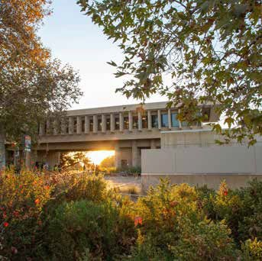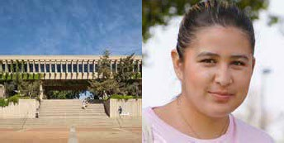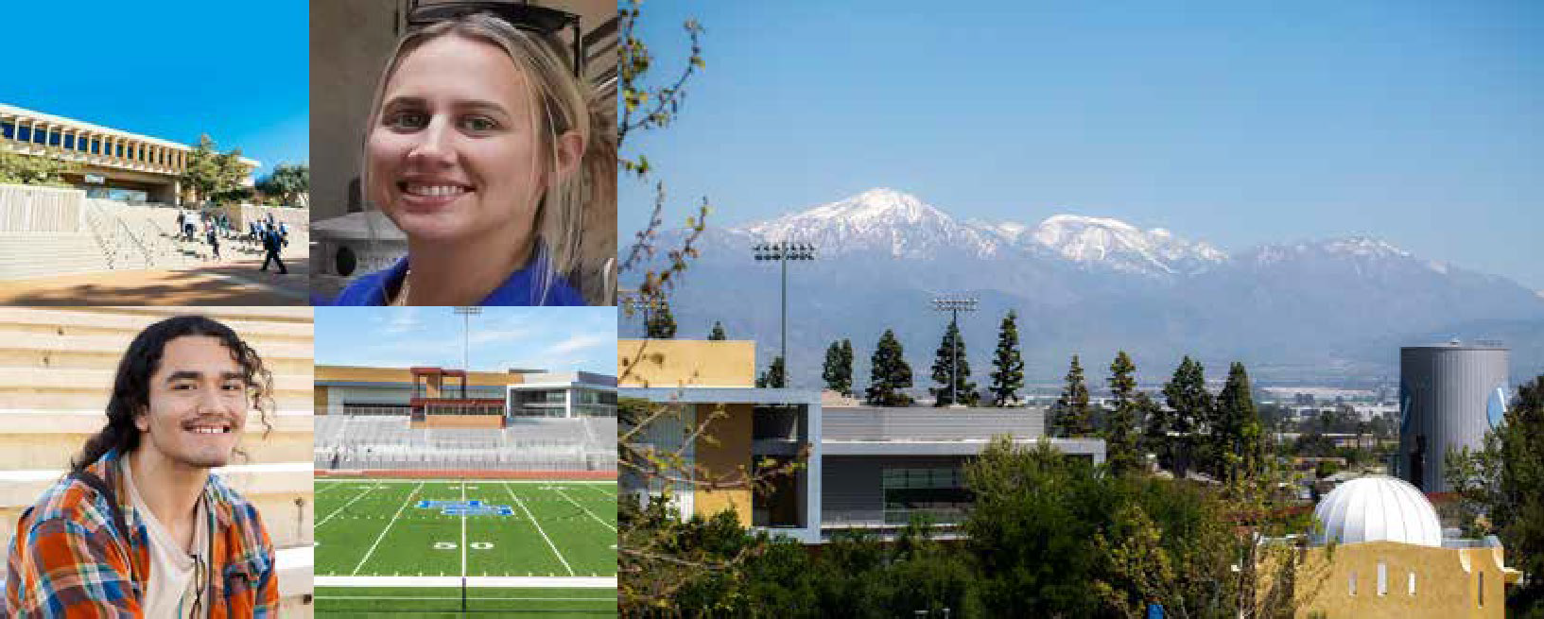

21 of 25

DRAFT

# 12. APPENDICES

### APPENDIX A

List of High Schools Served by San Bernardino Valley College and Crafton Hills College.

###### SAN BERNARDINO VALLEY COLLEGE

Bear Valley Unified School District

Big Bear High School

Rim of the World School District

Rim of the World

**San Bernardino City Unified School District**

Arroyo Valley High School Cajon High School

DRAFT

Indian Springs High School Inland Career Education Center Pacific High School

Rialto Unified District

Carter High School

Eisenhower High School

Milor High School

Rialto High School

Rialto Adult School

San Andreas High School

San Bernardino High School

San Gorgonio High School

Sierra High School

Adult Schools

Colton Rialto

San Bernardino City

###### CRAFTON HILLS COLLEGE

Redlands Unified School District

Redlands High School

Redlands East Valley High School Citrus Valley High School Orangewoo**d** High School

**Yucaipa-Calimesa Joint Unified** Yucaipa High School

Green Valley High School

Oak View High School

**SBCUSD Virtual Learning Academ**y

**Middle School College**

Charters

Entrepreneur High School Excelsior High School

Learn4Life

Options for Youth San Bernardino Norton Science & Language Academy Real Journey Academy -Entrepreneur

Springs Charter PAL Charter

Colton Joint Unified School District

Bloomington High School Colton High School

Grand Terrace High School

Slover Mountain High School

Charters

The Grove School Sage Oak

**Adult Schools** Redlands Yucaipa

### APPENDIX B

DRAFT

###### 

### DUAL ENROLLMENT RESOURCES

DRAFT

This section offers a centralized hub of links and materials that support the SBCCD Dual Enrollment Program, providing stakeholders with streamlined access to essential strategic documents, presentations, and recent updates.

##### RESOURCES

**VISION 2030:** High-level strategic outlook for the future of SBCCD.

**SBCCD DSO PLAN:** Comprehensive District Support Operations Plan.

**SBVC DUAL ENROLLMENT HOME PAGE:** Program information, application, and resources.

**CHC DUAL ENROLLMENT HOME PAGE:** Program information, application, and resources.

**DUAL ENROLLMENT SPRING 2024 UPDATE POWERPOINT:** DSO Presentation

detailing updates and progress in the Dual Enrollment program.

###### MEMORANDA OF UNDERSTANDING WITH PARTNER HIGH SCHOOLS:

Agreements/MOUs can be found at [CHC Dual Enrollment](https://www.craftonhills.edu/admissions-and-records/dual-enrollment-program/index.php) & [SBVC Dual Enrollment](https://www.valleycollege.edu/admissions-records/admissions/hs_concurrent_enroll.php).

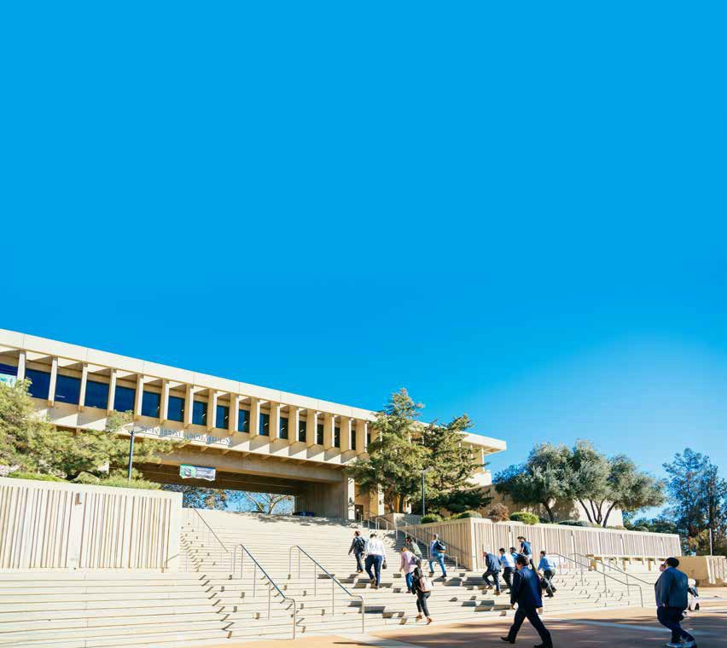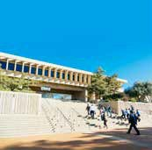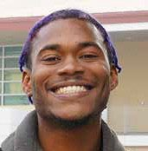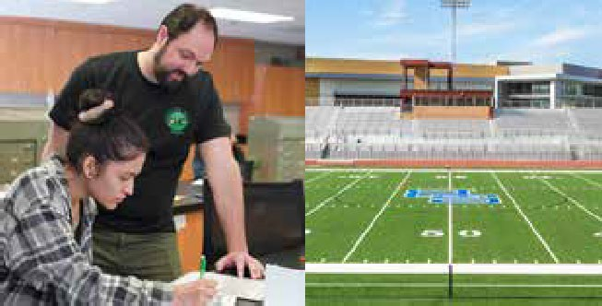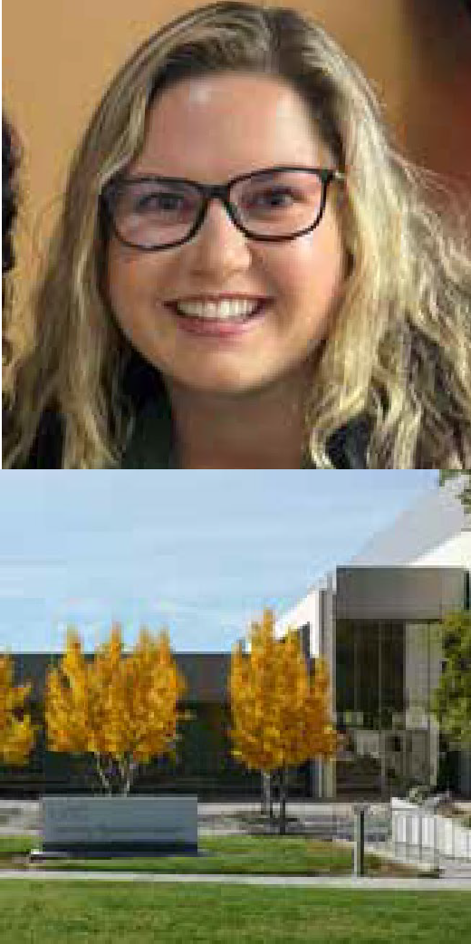

DRAFT

25 of 25

1. In 2023-2024, one student has a recorded error in birthdate. In Fall 2024, there are seven students under 14.